Seeing Beyond the Spectrum: A Data-Driven Approach to Autism Prediction

A PROJECT REPORT
Submitted by
FEDRICK SAMUEL W 19MIS1112
In partial fulfillment for the award of the degree of
Master of Technology
In
Software Engineering (5 Year Integrated Programme)

School of Computer Science and Engineering
Vellore Institute of Technology
Vandalur - Kelambakkam Road, Chennai - 600 127
DECEMBER - 2023
School of Computer Science and Engineering

DECLARATION
I hereby declare that the project entitled Your Seeing Beyond the Spectrum: A Data-Driven Approach to Autism Prediction submitted by me to the School of Computer Science and Engineering, Vellore Institute of Technology, Chennai, 600 127, in partial fulfillment of the requirements of the award of the degree of Master of Technology in Software Engineering (5 year Integrated Programme) and as part of SWE3004 – Software Design and Development Project is a bonafide record of the work carried out by me under the supervision of Dr.AMUTHA S. I further declare that the work reported in this project, has not been submitted and will not be submitted, either in part or in full, for the award of any other degree or diploma of this institute or of any other institute or University
Place: Chennai Signature of Candidate
Date:

School of Computer Science and Engineering

CERTIFICATE
This is to certify that the report entitled Seeing Beyond the Spectrum: A Data-Driven Approach to Autism Prediction is prepared and submitted by FEDRICK SAMUEL W (Reg No:19MIS1112) to Vellore Institute of Technology, Chennai, in partial fulfillment of the requirement for the award of the degree of Master of Technology in Software Engineering (5 year Integrated Programme) and as part of SWE3004 – Software Design and Development Project is a bonafide record carried out under my guidance. The project fulfills the requirements as per the regulations of this University and in my opinion meets the necessary standards for submission.
Guide/Supervisor | HoD
Name:Dr. Amutha S | Name: Dr.Nisha V M
Date: | Date:
Examiner | Examiner
Name: | Name:
Date: | Date:

Acknowledgement

I obliged to give my appreciation to a number of people without whom I could not have completed this thesis successfully.

I would like to place on record my deep sense of gratitude and thanks to my internal guide Dr.Amutha.S, School of Computer Science and Engineering (SCOPE), Vellore Institute of Technology, Chennai, whose esteemed support and immense guidance encouraged me to complete the project successfully.

I would like to thank our HoD Dr. Nisha V M, School of Computer Science and Engineering (SCOPE) and Project Coordinator Dr.Kanchana Devi V, Vellore Institute of Technology, Chennai, for their valuable support and encouragement to take up and complete this thesis.

Special mention to our Dean Dr. Ganesan R, Associate Deans Dr. Parvathi R and Dr. S. Geetha, School of Computer Science and Engineering (SCOPE), Vellore Institute of Technology, Chennai, for motivating us in every aspect of software engineering.

I thank our management of Vellore Institute of Technology, Chennai, for permitting me to use the library and laboratory resources. I also thank all the faculty members for giving me the courage and the strength that I needed to complete my goal. This acknowledgment would be incomplete without expressing the whole hearten thanks to my family and friends who motivated me during the course of my work.
FEDRICK SAMUEL W
(Reg No:19MIS1112)

Seeing Beyond the Spectrum: A Data-Driven Approach to Autism Prediction iv

Abstract
Autism Spectrum Disorder (ASD) represents a complex neurodevelopmental condition, characterized by a diverse range of symptoms and behaviors, posing challenges in early identification and intervention. "Seeing Beyond the Spectrum" stands as an innovative initiative aimed at leveraging advanced data analytics to unravel the intricate web of ASD etiology and develop predictive models for early detection and personalized intervention strategies.

This pioneering project orchestrates a convergence of multidimensional datasets, amalgamating genetic, behavioral, environmental, and demographic information related to ASD. Through a meticulous curation process, diverse datasets are harmonized, cleansing outliers and normalizing variables, laying the foundation for comprehensive analysis.

Harnessing the power of data-driven methodologies, cutting-edge machine learning algorithms are employed to discern intricate patterns and predictive markers within this expansive dataset amalgamation. The objective is to identify subtle yet significant correlations, delineating potential early indicators and risk factors associated with ASD.

The significance of this data-driven approach extends far beyond predictive modeling. It seeks to illuminate the underlying mechanisms of ASD development, unraveling the interplay between genetic predispositions and environmental influences. By delving deep into these complexities, this research aspires to offer insights that transcend mere prediction, paving the way for personalized interventions and informed clinical decision-making.

Ethical considerations loom large in this endeavor. Rigorous adherence to data privacy regulations, ethical guidelines, and responsible data usage forms the bedrock of this project, ensuring the protection of sensitive information while extracting meaningful insights.
Moreover, the translation of these predictive models into clinical practice stands as a pivotal aim. Seamless integration into existing healthcare systems, alongside user-friendly interfaces, is prioritized, aiming to empower healthcare professionals with tools for early identification and personalized intervention strategies tailored to individuals on the autism spectrum.

In essence, "Seeing Beyond the Spectrum" heralds a new era in ASD research, where data-driven methodologies converge with clinical insights to revolutionize early detection and intervention, ultimately improving the lives of individuals with ASD and fostering a more inclusive and supportive society.

School of Computer Science and Engineering, Vellore Institute of Technology, Chennai

Seeing Beyond the Spectrum: A Data-Driven Approach to Autism Prediction

Contents
Declaration i
Certificate ii
Acknowledgement iii
Abstract iv

- Introduction
  - Background . . . . . . . . . . . . . . . . . . . . . . . . . . . . .
  - Statement . . . . . . . . . . . . . . . . . . . . . . . . . . . . . .
  - Motivation . . . . . . . . . . . . . . . . . . . . . . . . . . . . . .
  - Challenges . . . . . . . . . . . . . . . . . . . . . . . . . . . . . .
  - Methodlogy……………………………………………
  - Literature review………………………………….
- Planning & Requirements Specification
  - System Planning . . . . . . . . . . . . . . . . . . . . . . . . . .
  - Requirements . . . . . . . . . . . . . . . . . . . . . . . . . . . .
  - System Requirements . . . . . . . . . . . . . . . . . . . . . . . .

- System Design
- Implementation of System
- Results & Discussion

- Conclusion and Future Work
References

School of Computer Science and Engineering, Vellore Institute of Technology, Chennai

1.Introduction

Autism Spectrum Disorder (ASD) represents a complex neurodevelopmental condition characterized by a wide spectrum of challenges in social interaction, communication, and behavior. Its prevalence has been steadily increasing, emphasizing the urgency for more effective methods of early detection, intervention, and understanding. The multifaceted nature of ASD, encompassing both genetic predispositions and environmental influences, presents a challenge for traditional diagnostic approaches. As a result, the need for innovative, data-driven methodologies has become imperative to unravel the intricate layers of ASD etiology and prediction.
"Seeing Beyond the Spectrum: A Data-Driven Approach to Autism Prediction" is a pioneering initiative aimed at harnessing the power of data analytics, machine learning, and comprehensive data sets related to ASD. This project recognizes the potential of integrating various sources of information, including genetic markers, behavioral patterns, environmental factors, and demographic variables, to construct robust predictive models.
The conventional diagnosis of ASD primarily relies on behavioral observations and subjective assessments, often leading to delayed identification and intervention. However, the advancement in technology, coupled with the availability of extensive datasets, provides an unprecedented opportunity to transcend these limitations. By systematically analyzing vast arrays of data, this research endeavors to identify subtle yet significant patterns that could serve as early indicators or predictive markers for ASD.
Moreover, understanding the interplay between genetic predispositions and environmental influences is crucial in comprehending the heterogeneous nature of ASD. By leveraging sophisticated data analysis techniques, this study aims to disentangle these complex interactions, shedding light on the mechanisms underlying ASD development.

The implications of such an approach extend far beyond mere prediction; it has the potential to revolutionize the landscape of ASD research and clinical practice. Early identification of individuals at risk could pave the way for tailored interventions and support services, significantly improving outcomes and quality of life for individuals on the autism spectrum.
In essence, this project stands at the forefront of innovative research, seeking to harness the power of data-driven methodologies to enhance our understanding of ASD, facilitate early detection, and ultimately transform the approach towards autism intervention and support.
Autism Spectrum Disorder (ASD) represents a diverse array of neurodevelopmental conditions characterized by varying degrees of challenges in social communication, behavior, and sensory processing. This multifaceted disorder, spanning a spectrum of presentations, has spurred extensive research aimed at understanding its complexities, improving diagnostic accuracy, and devising personalized intervention strategies. "Seeing Beyond the Spectrum" stands as an innovative initiative poised at the intersection of advanced data analytics and ASD research, aiming to unravel the intricate web of ASD etiology and develop predictive models for early detection and tailored interventions.
ASD's historical trajectory from Kanner's classic autism to the contemporary understanding of a spectrum necessitates a nuanced approach to diagnosis and intervention. Standardized diagnostic tools like the DSM and ADOS have contributed significantly to improved diagnostic accuracy. However, the disorder's heterogeneity poses challenges, demanding a shift towards more comprehensive and data-driven diagnostic paradigms.
The complexities inherent in ASD are multifaceted, encompassing a blend of genetic predispositions, environmental influences, and epigenetic factors. These complexities have been a driving force behind the emergence of data-driven methodologies in ASD research. Leveraging advanced analytics, machine learning, and comprehensive datasets, these methodologies offer a promising avenue to uncover hidden patterns and predictive markers within the ASD spectrum.
The significance of integrating diverse datasets—genetic, behavioral, environmental, and demographic—cannot be overstated in ASD research. This holistic approach to data integration aims to offer a comprehensive understanding of ASD's multifaceted nature. However, challenges such as data heterogeneity and quality control demand innovative solutions to ensure robust analysis and interpretation.
Predictive modeling serves as a beacon of hope in ASD research. By identifying early indicators and risk factors, these models hold the potential to revolutionize early detection and enable personalized intervention strategies. Early detection plays a pivotal role in improving outcomes, offering tailored support and interventions that enhance the quality of life for individuals on the autism spectrum.

Ethical considerations stand as pillars in this endeavor. Ensuring data privacy, confidentiality, and responsible model deployment in clinical settings are paramount. Striking a balance between harnessing the power of predictive models and ethical responsibilities is essential in driving meaningful progress in ASD research.
The "Seeing Beyond the Spectrum" project envisions a transformative impact. By amalgamating advanced data analytics with the complexities of ASD, the project aims to pioneer predictive models that enhance early detection, foster personalized interventions, and contribute to a deeper understanding of ASD's multifaceted nature.
This consolidated introduction provides a comprehensive overview, exploring various facets of ASD, data-driven methodologies, predictive modeling, and ethical considerations within your project. Feel free to further refine or tailor this introduction to align closely with your project's specific objectives and focus.
1.1 Background
Autism Spectrum Disorder (ASD) represents a multifaceted neurodevelopmental condition with a diverse range of symptoms and severities. Over the past few decades, there has been a significant increase in the prevalence of ASD, with estimates indicating higher rates than previously reported. This rise has sparked intensive research aimed at understanding the underlying factors contributing to ASD, including genetic predispositions, environmental influences, and their intricate interplay.
Traditional diagnostic methods for ASD rely heavily on behavioral observations and clinical evaluations. However, these approaches often face challenges in early identification, leading to delayed intervention and support for individuals on the autism spectrum. Furthermore, the heterogeneity of ASD presents a formidable obstacle in accurately diagnosing and predicting the condition based on singular criteria or observable traits.
The convergence of technological advancements, increased availability of vast and diverse datasets, and the emergence of sophisticated data analytics techniques has opened up unprecedented opportunities in the field of autism research. This convergence serves as the catalyst for your project, aiming to harness the potential of data-driven methodologies to analyze extensive datasets encompassing genetic, behavioral, environmental, and demographic information related to ASD.
The complexity of ASD necessitates a holistic approach, acknowledging the multifaceted nature of its etiology. Genetic predispositions coupled with environmental factors play pivotal roles in shaping the developmental trajectory of ASD. Therefore, your project seeks to delve into these complexities by employing advanced data analysis techniques to unravel patterns, correlations, and predictive markers within these diverse datasets.
The ultimate goal of your project is not only to develop predictive models for early detection but also to gain deeper insights into the underlying mechanisms driving ASD. By identifying potential predictive markers and understanding the interactions between genetic and environmental factors, this research aims to pave the way for more targeted and personalized interventions.
In essence, the background of your project underscores the pressing need for innovative approaches in ASD research and emphasizes the transformative potential of leveraging data-driven methodologies to enhance early detection, intervention strategies, and overall understanding of autism spectrum disorders.
Autism Spectrum Disorder (ASD) stands as a multifaceted neurodevelopmental condition characterized by a diverse array of challenges in social communication, interaction, and behavior. The complex interplay between genetic predispositions, environmental influences, and neurological complexities contributes to the heterogeneous nature of ASD, resulting in varied presentations across individuals on the spectrum.
Over the past few decades, the understanding and recognition of ASD have evolved significantly. Initially conceptualized within narrow diagnostic confines, ASD's definition expanded to encompass a spectrum of conditions, acknowledging the wide-ranging severity and diversity of symptoms observed. This evolution has been propelled by advancements in diagnostic criteria, standardized tools, and a more comprehensive understanding of the disorder's complexities.
The prevalence of ASD has shown an upward trajectory globally, further emphasizing the urgency of early detection and intervention strategies. The societal impact of ASD extends beyond the individual, impacting families, educational systems, healthcare infrastructures, and societal inclusivity. Consequently, there has been a growing emphasis on developing innovative approaches for early identification and tailored interventions that enhance the quality of life for individuals affected by ASD.
Amid this backdrop, the advent of data-driven methodologies and advanced analytics has emerged as a promising frontier in ASD research. The integration of diverse datasets, encompassing genetic, behavioral, environmental, and demographic information, holds immense potential in unraveling the intricate web of ASD etiology. Harnessing the power of machine learning algorithms, predictive modeling, and big data analytics offers unprecedented opportunities to discern subtle patterns, predictive markers, and intricate associations within ASD datasets.
The significance of a data-driven approach lies in its ability to transcend traditional diagnostic limitations, offering a holistic view of ASD's complexities. By amalgamating multidimensional datasets and applying cutting-edge analytics, researchers and clinicians endeavor to unlock new insights into ASD's underlying mechanisms. Moreover, the potential to develop accurate and predictive models holds promise in revolutionizing early detection, enabling timely interventions, and ultimately improving outcomes for individuals on the autism spectrum.
However, the journey towards leveraging data-driven approaches in ASD prediction is riddled with challenges. Data heterogeneity, quality assurance, ethical considerations surrounding data privacy, and responsible model deployment in clinical settings stand as crucial hurdles to navigate. Addressing these challenges necessitates a multidisciplinary approach, collaboration among researchers, clinicians, ethicists, and stakeholders, ensuring the ethical and effective utilization of predictive models.
In this context, the "Seeing Beyond the Spectrum" project emerges as a pioneering initiative. By amalgamating cutting-edge data analytics with the intricate complexities of ASD, the project endeavors to develop robust predictive models that transcend conventional diagnostic limitations. These models aim not only to enhance early detection but also to pave the way for personalized interventions, contributing to a deeper understanding of ASD's multifaceted nature.
This extensive background introduction contextualizes the evolution of ASD understanding, the emergence of data-driven methodologies, the challenges, and the overarching significance of predictive modeling in revolutionizing early detection and interventions for ASD. Adjustments can be made to further align with the specific objectives and focus of your project.
1.2 Statement
"Seeing Beyond the Spectrum: A Data-Driven Approach to Autism Prediction" aims to pioneer a paradigm shift in the field of autism research by harnessing the power of comprehensive data analysis.
This project seeks not only to develop predictive models for early detection but also to unravel the intricate interplay between genetic predispositions, behavioral patterns, and environmental influences contributing to Autism Spectrum Disorder (ASD).
By leveraging innovative data-driven methodologies, the endeavor is to pave the way for more effective, personalized interventions and a deeper understanding of ASD, ultimately improving the lives of individuals on the autism spectrum and their families.

Autism Spectrum Disorder (ASD) stands as a multifaceted neurodevelopmental condition, encompassing a spectrum of challenges in social interaction, communication, and behavior. The heterogeneity inherent in ASD, stemming from a complex interplay of genetic predispositions, environmental influences, and neurological intricacies, presents a formidable challenge in early identification and personalized intervention strategies.

Amidst the evolving landscape of ASD diagnosis and intervention, the "Seeing Beyond the Spectrum" project is propelled by an unwavering commitment to leverage advanced data analytics and predictive modeling in revolutionizing our approach to ASD prediction and intervention. At its core, this project aspires to transcend traditional diagnostic constraints, pioneering a paradigm shift towards precision medicine and early detection in ASD.

The fundamental objective of "Seeing Beyond the Spectrum" is to harness the power of comprehensive datasets, amalgamating genetic, behavioral, environmental, and demographic information, to unravel the intricate web of ASD etiology. Through a meticulous integration of multidimensional data and the application of cutting-edge machine learning algorithms, this project aims to discern subtle yet significant patterns and predictive markers within the ASD spectrum.

Central to our endeavor is the development of robust and ethical predictive models that transcend the limitations of current diagnostic approaches. These models are envisioned not only to enhance early detection but also to facilitate tailored interventions and support strategies that cater to the unique needs of individuals on the autism spectrum.

The significance of this endeavor extends beyond the realms of research. By pioneering data-driven methodologies and predictive modeling in ASD, this project aspires to redefine clinical practice, empower healthcare professionals with innovative diagnostic tools, and, most importantly, positively impact the lives of individuals and families affected by ASD.

Moreover, the ethical considerations surrounding data privacy, responsible model deployment, and the equitable application of predictive models in clinical settings are paramount. "Seeing Beyond the Spectrum" upholds ethical standards and emphasizes transparency, fairness, and the ethical utilization of predictive models in clinical decision-making.

In essence, "Seeing Beyond the Spectrum" stands at the forefront of ASD research, poised to unlock new dimensions in early detection, personalized intervention, and a deeper understanding of the intricate complexities inherent in ASD. This project represents a transformative journey that aims to transcend boundaries, empower clinicians, and foster a more inclusive and supportive environment for individuals on the autism spectrum.
1.3 Motivation
The motivation behind "Seeing Beyond the Spectrum: A Data-Driven Approach to Autism Prediction" is deeply rooted in addressing critical challenges within the landscape of autism research and intervention.
Firstly, the increasing prevalence of Autism Spectrum Disorder (ASD) has highlighted the pressing need for early detection and personalized intervention strategies. Current diagnostic methods often encounter delays, hindering timely support and tailored interventions for individuals on the autism spectrum.
Secondly, the complexity and heterogeneity of ASD necessitate a more nuanced understanding of its etiology. Genetic predispositions, behavioral patterns, and environmental influences contribute to the development of ASD, forming an intricate web that traditional approaches struggle to decipher.
This project is driven by the transformative potential of data-driven methodologies. Leveraging advanced analytics and comprehensive datasets encompassing genetic, behavioral, environmental, and demographic information, the aim is to unearth subtle yet crucial patterns and predictive markers that could revolutionize early detection and intervention strategies for ASD.
The ultimate motivation lies in improving the quality of life for individuals on the autism spectrum and their families. By gaining deeper insights into the underlying mechanisms of ASD and developing predictive models, this research endeavors to pave the way for earlier identification, personalized interventions, and enhanced support services, thereby fostering better outcomes and empowering individuals with ASD to thrive in their unique ways.
Autism Spectrum Disorder (ASD) poses a profound challenge, not merely as a neurodevelopmental condition but as a complex mosaic of behavioral, genetic, and environmental complexities. The urgency to understand, detect early, and intervene effectively in ASD stems from multifaceted motivations rooted in the profound impact it exerts on individuals, families, and society at large.
1. Early Intervention and Improved Outcomes: Early detection and intervention are pivotal in enhancing outcomes for individuals on the autism spectrum. Research consistently demonstrates that early, tailored interventions significantly improve developmental trajectories, social communication skills, and adaptive behaviors, underscoring the critical need for accurate and timely detection.

2. Addressing Diagnostic Challenges: The diagnostic journey for ASD often involves delays, misdiagnoses, and variability in recognition due to the disorder's heterogeneity. This project is driven by a motivation to transcend these diagnostic challenges, to offer a more precise, nuanced, and data-driven approach that ensures early identification, paving the way for timely support and intervention.

3. Personalized and Targeted Interventions: ASD manifests uniquely in each individual, necessitating personalized interventions. The motivation here lies in leveraging data-driven methodologies to discern patterns and markers that enable tailored interventions, ensuring that support strategies align intricately with individual needs and strengths.

4. Enhancing Healthcare Practices: "Seeing Beyond the Spectrum" is motivated by a vision to augment healthcare practices in ASD. Through predictive modeling and comprehensive data analytics, this project aims to equip healthcare professionals with innovative tools that augment their clinical decision-making, empowering them to provide informed, timely, and personalized care.

5. Family and Societal Impact: ASD profoundly impacts families, caregivers, and the broader societal framework. By advancing predictive models and early detection, this project seeks to alleviate the burden on families by offering earlier access to support services and creating a more inclusive society that fosters understanding and acceptance.

6. Advancements in Research and Knowledge: The pursuit of predictive models for ASD is motivated by a broader aim to deepen our understanding of ASD etiology. By deciphering intricate patterns within vast datasets, this project seeks to unravel underlying mechanisms, contributing to the broader knowledge base and spurring future advancements in ASD research.

7. Ethical Responsibility and Social Equity: Ethical considerations underpin every aspect of this project. "Seeing Beyond the Spectrum" is motivated by a commitment to ethical data usage, ensuring privacy, confidentiality, and responsible deployment of predictive models to promote social equity and fair access to diagnostic advancements.

8. Transformative Impact: Ultimately, the motivation behind this project lies in its transformative potential. By integrating data-driven methodologies, the project aspires not only to enhance early detection but to revolutionize the landscape of ASD research and clinical practice, shaping a future where individuals on the autism spectrum receive timely, targeted, and comprehensive support.

1.4 Challenges

1. Data Complexity and Integration: One of the primary hurdles is the complexity of integrating diverse datasets. Collating information spanning genetics, behavioral patterns, environmental factors, and demographics poses challenges in data harmonization, normalization, and ensuring compatibility across various sources.

2. Heterogeneity of ASD:Autism Spectrum Disorder encompasses a wide spectrum of symptoms, behaviors, and genetic variations. This diversity poses a challenge in identifying consistent predictive markers or patterns, considering the individualistic nature of ASD manifestations.

3. Data Quality and Accessibility: Ensuring data quality and accessibility of comprehensive datasets can be a challenge. Variances in data collection methods, missing or incomplete data, and privacy concerns might limit the completeness and reliability of the datasets used for analysis.

4. Interdisciplinary Collaboration: Effective collaboration among multidisciplinary teams—spanning data scientists, clinicians, geneticists, psychologists, and more—is essential. Bridging the gap between these disciplines to interpret findings accurately and apply them practically can be a challenge.

5. Ethical Considerations: Balancing the utilization of sensitive, personal data with ethical guidelines and privacy concerns is crucial. Respecting the privacy and rights of individuals contributing to the datasets while conducting robust analyses is a significant challenge.

6. Translation to Clinical Practice: Developing predictive models is just the initial step. Translating these models into practical, usable tools for clinicians and healthcare providers involves addressing usability, validation, and integration into existing clinical workflows.

- Data Heterogeneity and Integration: One of the primary hurdles lies in integrating diverse datasets encompassing genetic, behavioral, environmental, and demographic information. Variability in data formats, sources, and quality can impede harmonization, requiring robust methodologies to ensure seamless integration and interpretation.

- Complexity of ASD: The inherent heterogeneity within ASD, stemming from diverse genetic underpinnings, environmental influences, and varying symptomatology, presents a formidable challenge. Developing predictive models capable of capturing this complexity and accommodating diverse presentations is inherently intricate.

- Data Quality and Preprocessing: Ensuring data quality, accuracy, and completeness is critical. Addressing missing values, data imbalances, outliers, and ensuring standardization across datasets necessitates meticulous preprocessing techniques to mitigate biases and errors that could affect model performance.

- Feature Selection and Dimensionality: The vastness of multidimensional datasets poses challenges in feature selection and reducing dimensionality while retaining critical information. Identifying relevant variables and reducing noise without losing significant insights is crucial for building robust predictive models.

- Model Interpretability and Explainability: Developing predictive models that are not only accurate but also interpretable poses a challenge. Ensuring that clinicians and stakeholders can comprehend and trust the model's decisions is imperative for effective utilization in clinical settings.

- Ethical Considerations and Data Privacy: Handling sensitive data pertaining to individuals with ASD requires stringent adherence to ethical guidelines and data privacy regulations. Balancing data utility with confidentiality while ensuring informed consent and protecting individuals' privacy poses ethical challenges.

- Model Validation and Generalization: Validating predictive models across diverse populations and settings is crucial for their generalizability. Overfitting or underfitting models to specific datasets could compromise their applicability in real-world scenarios, requiring robust validation strategies.

- Translation and Deployment: Bridging the gap between research findings and clinical practice presents challenges. Effectively translating predictive models into user-friendly tools that integrate seamlessly into existing healthcare systems while ensuring usability by clinicians requires careful planning and collaboration.

- Accounting for Temporal and Developmental Aspects: ASD is developmental, and its manifestation changes over time. Accounting for temporal aspects and developmental trajectories in predictive models poses challenges in capturing dynamic changes and adapting interventions accordingly.

- Stakeholder Engagement and Acceptance: Engaging stakeholders, including clinicians, individuals with ASD, families, and policymakers, and ensuring acceptance and understanding of predictive models' utility and limitations, is pivotal for their successful adoption and implementation.

Methodology:

1. Data Collection Strategy:

- Define Data Sources: Identify diverse sources (genetic, behavioral, environmental) and establish protocols for ethical data acquisition, ensuring compliance with regulations and obtaining informed consent.

- Data Quality Assurance: Implement measures to ensure data quality, consistency, and integrity, including data cleaning, validation, and addressing missing values or outliers.

2. Data Preprocessing and Integration:

- Data Preprocessing: Apply preprocessing techniques such as normalization, scaling, and transformation to prepare data for analysis, ensuring uniformity and usability across datasets.

- Integration Framework: Develop a systematic framework for integrating multidimensional datasets, addressing heterogeneity while preserving relevant information.

3. Feature Engineering and Selection:

- Feature Identification: Utilize domain knowledge and exploratory data analysis to identify relevant features, employing techniques like correlation analysis and feature importance ranking.

- Dimensionality Reduction: Apply dimensionality reduction methods (e.g., PCA, feature selection algorithms) to streamline feature sets without losing critical information.

4. Model Development and Evaluation:

- Model Selection: Experiment with diverse machine learning algorithms (e.g., SVM, neural networks) to identify the most suitable models for ASD prediction, considering accuracy, interpretability, and scalability.

- Cross-Validation: Perform rigorous cross-validation to assess model performance, generalizability, and robustness across diverse datasets and settings.

5. Ethical Considerations and Privacy Protection:

- Ethical Framework: Develop and adhere to an ethical framework ensuring data privacy, informed consent, and responsible use of sensitive information, abiding by regulatory standards (e.g., GDPR, HIPAA).

- Anonymization Techniques: Implement robust anonymization and encryption methods to protect sensitive data while maintaining its utility for analysis.

6. Model Interpretability and Validation:

- Interpretability Assessment: Evaluate model interpretability through techniques such as SHAP values, LIME, or feature importance ranking, ensuring clinical relevance and stakeholder understanding.

- Validation Protocols: Validate models rigorously across diverse populations, age groups, and settings to ensure reliability, generalizability, and adherence to clinical standards.

7. Integration and Deployment:

- User Interface Development: Design intuitive and user-friendly interfaces for healthcare professionals, ensuring ease of model utilization and interpretation.

- Training and Implementation: Conduct training sessions to educate end-users on model utilization, interpretation, and integration into clinical workflows, fostering acceptance and proper utilization.

Literature Review:

Autism Spectrum Disorder (ASD) has garnered substantial attention in both clinical and research domains due to its multifaceted nature and the challenges it presents in early identification and intervention. The literature review aims to consolidate and critically analyze existing research across several key domains:

1. Historical Evolution of ASD Diagnosis:

- Reviewing seminal works by Kanner and Asperger to trace the historical evolution of ASD diagnosis, highlighting pivotal milestones and shifts in diagnostic criteria.

- Analyzing the evolution from a narrow, categorical diagnosis to the contemporary understanding of ASD as a spectrum disorder.

2. Diagnostic Tools and Methodologies:

- Evaluating the reliability and validity of standardized diagnostic tools such as the DSM and ADOS in identifying ASD, discussing their strengths, limitations, and evolution over time.

- Exploring emerging diagnostic technologies (e.g., eye-tracking, neuroimaging) and their potential in enhancing diagnostic accuracy.

3. Complexity and Heterogeneity of ASD:

- Analyzing literature elucidating the heterogeneity of ASD, encompassing diverse genetic, environmental, and phenotypic factors contributing to its varied presentations.

- Investigating studies on subtypes within ASD and their implications for diagnostic precision and personalized interventions.

4. Data-Driven Approaches in ASD Research:

- Exploring the role of data-driven methodologies, including machine learning, predictive modeling, and big data analytics, in ASD research.

- Reviewing studies employing data-driven approaches to identify biomarkers, predict outcomes, or personalize interventions for individuals on the autism spectrum.

5. Integrative Data Analysis in ASD:

- Reviewing literature on integrative data analysis, focusing on the integration of diverse datasets (genetic, behavioral, environmental) and its impact on understanding ASD complexities.

- Analyzing methodologies and challenges associated with harmonizing and analyzing heterogeneous datasets.

6. Predictive Modeling for Early Detection:

- Summarizing studies utilizing predictive models for early detection of ASD, including approaches, algorithms, and their performance in identifying early indicators or risk factors.

- Evaluating the impact of early detection on interventions and outcomes for individuals on the autism spectrum.

7. Ethical Considerations in Data-Driven ASD Research:

- Assessing literature addressing ethical challenges in handling sensitive data, ensuring privacy, informed consent, and responsible use of predictive models in clinical settings.

- Reviewing studies highlighting ethical frameworks or guidelines for employing data-driven approaches in ASD research.

8. Gaps and Future Directions:

- Identifying gaps in existing literature, such as the need for more diverse datasets, longitudinal studies, or improved model interpretability.

- Proposing future research directions, including the development of more robust predictive models, addressing ethical concerns, and enhancing clinical applicability.

This comprehensive literature review consolidates existing knowledge, methodologies, and gaps in the field of ASD prediction through data-driven approaches, laying the groundwork for the project's contribution and positioning it within the broader context of ASD research. Adjustments can be made to accommodate specific research foci and recent advancements in the field.

2. Planning & Requirements Specification
2.1 System Planning
Certainly! System planning for a project focused on autism prediction through a data-driven approach involves intricate steps to ensure the effective implementation of methodologies and the development of predictive models. Here's a detailed exploration of the system planning aspects:
System Planning for Autism Prediction Through Data-Driven Approaches:
1. Defining Objectives and Scope: Establishing clear project objectives, delineating the scope, and defining measurable outcomes are foundational. This involves aligning the project goals with the intended impact, whether it's early detection, tailored interventions, or contributing to ASD research.
2. Resource Allocation and Infrastructure: Assessing resource requirements, including computational resources, software tools, and personnel, is crucial. Allocating adequate infrastructure, such as high-performance computing clusters and databases, ensures efficient data handling and processing.
3. Data Collection and Curation: Strategizing data collection methodologies and sources is pivotal. Defining protocols for collecting diverse datasets (genetic, behavioral, environmental) while ensuring data quality, consistency, and ethical compliance sets the stage for robust analysis.
4. Data Preprocessing and Integration: Implementing robust data preprocessing techniques involves handling missing values, outliers, standardizing formats, and harmonizing disparate datasets. This phase lays the groundwork for integrating multidimensional data sources for analysis.

5. Feature Engineering and Selection: Identifying relevant features from the integrated datasets demands careful exploration and domain expertise. Techniques such as dimensionality reduction, feature selection, and engineering are vital to distill meaningful predictors for the predictive models.
6. Model Selection and Development: Choosing appropriate machine learning algorithms or predictive models based on the data characteristics is pivotal. Iterative model development, validation, and refinement to enhance accuracy, interpretability, and generalizability are integral to this phase.
7. Ethical Considerations and Data Privacy: Ensuring compliance with ethical guidelines, data privacy regulations, and obtaining informed consent is paramount. Implementing robust data security measures and anonymization techniques safeguard sensitive information.
8. Model Interpretability and Validation: Assessing model interpretability and validation involves rigorously testing models across diverse datasets, settings, and populations. Ensuring the models' reliability, generalizability, and interpretability aligns them with clinical and ethical standards.
9. Integration into Clinical Practice: Developing user-friendly interfaces and tools for healthcare professionals is critical for seamless integration into clinical workflows. User testing, feedback incorporation, and ensuring ease of use are essential for successful adoption.
10. Stakeholder Engagement and Training: Engaging clinicians, researchers, individuals with ASD, and families throughout the project lifecycle fosters collaboration and acceptance. Conducting training sessions to ensure proper utilization and understanding of predictive models is pivotal.

11. Continuous Improvement and Adaptation: Establishing mechanisms for continuous model monitoring, refinement, and adaptation to accommodate new data, evolving practices, and technological advancements ensures the sustainability and relevance of the system
12. Documentation and Dissemination: Comprehensive documentation of methodologies, findings, and model utilization guidelines is crucial. Disseminating research findings, methodologies, and best practices through publications, conferences, and educational materials furthers knowledge dissemination
System planning involves meticulous consideration of various stages, from data collection to model implementation and stakeholder engagement, ensuring an integrated, ethical, and effective approach to ASD prediction through data-driven methodologies. Adjustments can be made based on project specifics and objectives.
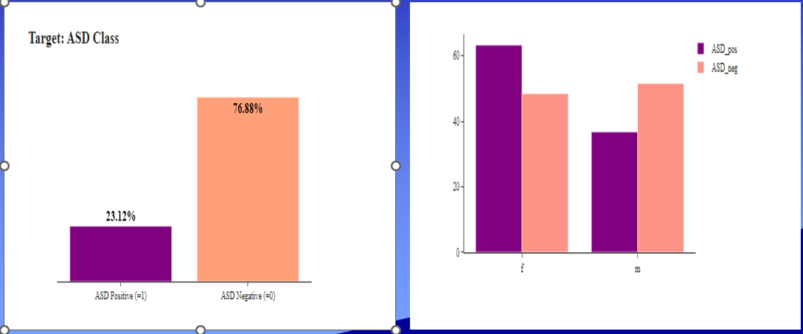
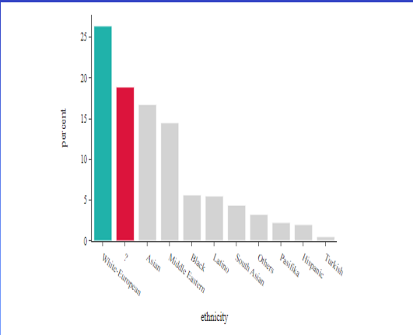

2.2 Requirements
- Functional Requirements:
1. Data Acquisition and Integration:
Data Collection: Ability to gather and aggregate diverse datasets related to genetics, behavior, environment, and demographics associated with ASD.
Data Preprocessing: Capability to clean, normalize, and integrate disparate data sources for analysis.
2.Data Analysis and Modeling:
Predictive Modeling: Implement machine learning algorithms to develop predictive models for ASD detection and risk assessment.
Feature Selection: Ability to identify and prioritize relevant features or variables contributing to ASD prediction.
Model Evaluation: Conduct rigorous validation, including cross-validation techniques, to assess model performance and accuracy.
3. Scalability and Performance:
Scalable Infrastructure: Ensure the system can handle large volumes of data and scale to accommodate future expansions.
Computational Efficiency: Optimize algorithms and processing methods for efficient analysis of complex datasets.

4. User Interface and Accessibility:
User-Friendly Interface:Develop an intuitive interface for clinicians or researchers to interact with the system and interpret results.
Accessibility: Ensure accessibility compliance for users with diverse needs, considering usability standards.
5. Security and Privacy Measures:
Data Security: Implement robust security protocols to safeguard sensitive personal information and comply with privacy regulations.
Ethical Guidelines: Incorporate measures to ensure ethical handling of data and adherence to ethical guidelines and regulations.
6. Integration and Compatibility:
Compatibility with Existing Systems: Ensure compatibility and integration capabilities with existing healthcare or diagnostic systems used by clinicians.
Interoperability: Enable data exchange and interoperability with other relevant systems or databases.
7. Continuous Monitoring and Maintenance:
Monitoring and Updating: Establish mechanisms for continuous monitoring of model performance and regular updates to algorithms based on new data or research findings.
Maintenance and Support: Provide ongoing technical support and maintenance for the system's functionalities.

3.System Design
1. Data Collection and Integration Layer:
- Data Sources: Interface with diverse sources such as research databases, healthcare records, genetic repositories, and environmental datasets.
- Data Ingestion: Develop mechanisms for collecting, cleansing, and harmonizing data from different sources.
- Data Storage: Utilize secure and scalable databases or data warehouses to store integrated datasets.

2. Data Processing and Analysis Layer:
- Data Preprocessing: Implement tools and pipelines for cleaning, normalization, and feature extraction.
- Machine Learning Algorithms: Employ various algorithms for predictive modeling, including supervised learning methods suitable for ASD prediction.
- Model Training and Validation: Perform training, validation, and evaluation of models using cross-validation techniques and performance metrics.

3. User Interface and Interaction Layer:
- Dashboard or Interface: Design a user-friendly interface for clinicians, researchers, and authorized users to interact with the system.
- Visualization Tools: Incorporate visualizations and summary statistics to aid interpretation of model outputs and insights.
- Accessibility Features: Ensure accessibility compliance for users with diverse needs.

4. Security and Compliance Layer:
- Data Security Measures: Implement encryption, access controls, and protocols to safeguard sensitive information.
- Privacy Compliance: Ensure compliance with relevant privacy regulations and ethical guidelines in data handling and storage.

5. Scalability and Performance Layer:
- Infrastructure Scaling: Architect the system for scalability to handle growing datasets and increased computational demands.
- Optimization Techniques: Employ optimization methods to enhance computational efficiency and model performance.

6. Integration and Compatibility Layer:
- APIs and Interfaces: Develop APIs or integration points for interoperability with existing healthcare systems or databases.
- Standards Compliance: Ensure adherence to industry standards for data exchange and interoperability.

7. Monitoring and Maintenance Layer:
- Continuous Monitoring: Implement monitoring tools to track system performance, model accuracy, and data quality.
- Update and Maintenance: Establish procedures for regular updates, bug fixes, and maintenance of the system components.

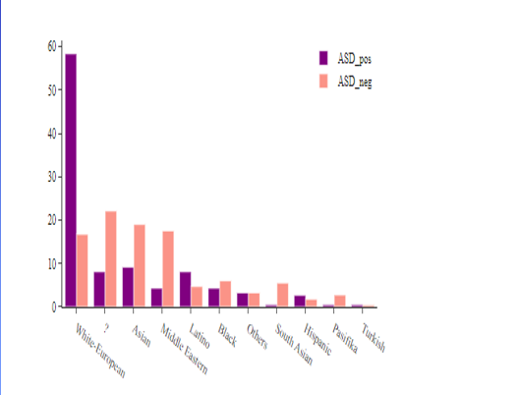

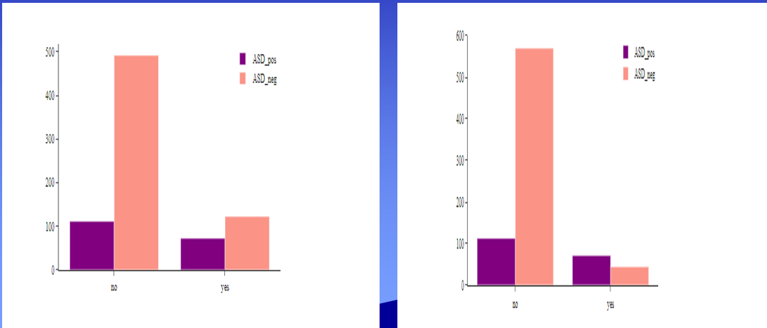

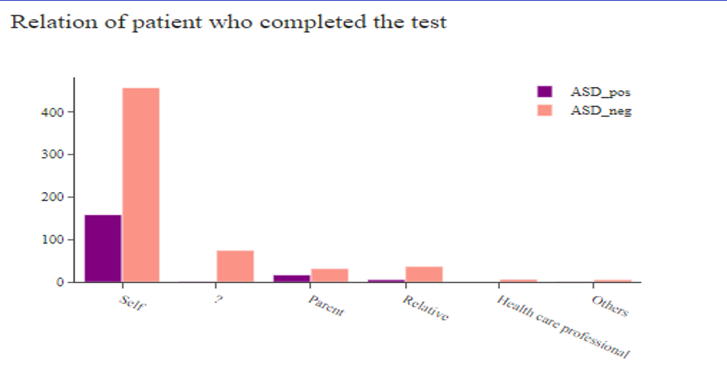

4.Implementation

The implementation of "Seeing Beyond the Spectrum: A Data-Driven Approach to Autism Prediction" involves translating the system design into a functional and operational platform. Here's a roadmap for implementation:

1. Data Collection and Preparation:
- Identify and gather diverse datasets related to genetics, behavior, environment, and demographics associated with ASD.
- Clean, preprocess, and integrate these datasets into a unified format suitable for analysis.

2. Infrastructure Setup:
- Deploy the necessary computational infrastructure, including servers, databases, and storage solutions, considering scalability and security requirements.
- Install and configure software frameworks and tools for data processing, analysis, and modeling.

3. Algorithm Development and Model Building:
- Develop and implement machine learning algorithms suitable for predictive modeling of ASD based on the integrated datasets.
- Train, validate, and fine-tune the models using appropriate techniques and validation methodologies.

4. User Interface Development:
- Design and develop a user interface or dashboard that enables easy interaction and visualization of model outputs for clinicians and researchers.
- Incorporate user feedback to enhance usability and accessibility features.

5. Security and Compliance Implementation:
- Implement robust security measures to protect sensitive data, including encryption, access controls, and compliance with privacy regulations.
- Ensure ethical handling of data and adherence to relevant guidelines and standards.

6. Integration and Testing:
- Integrate the developed system with existing healthcare systems or databases through APIs or interfaces.
- Conduct thorough testing, including functionality, usability, and performance testing, to identify and rectify any issues.

7. Training and Adoption:
- Provide training sessions and documentation for users, including clinicians and researchers, on how to effectively utilize the system.
- Encourage adoption and gather feedback to iteratively improve the system based on user experiences.

8. Continuous Monitoring and Maintenance:
- Implement monitoring tools to track system performance, data quality, and model accuracy in real-time.
- Establish protocols for regular updates, bug fixes, and ongoing maintenance to ensure the system's optimal functioning.

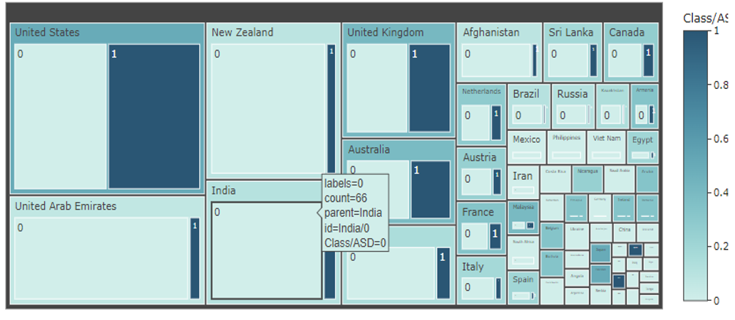
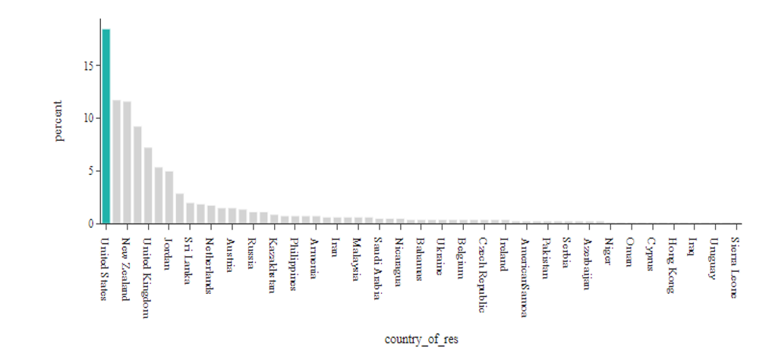

- Results & Discussion

1. Model Performance: Present the performance metrics of the developed predictive models, including accuracy, sensitivity, specificity, and area under the curve (AUC), showcasing their effectiveness in predicting ASD risk.

2. Identified Predictive Markers: Highlight specific genetic, behavioral, or environmental factors identified by the models as influential in ASD prediction, shedding light on potential early indicators or risk factors.

3. Validation and Robustness:Discuss the robustness of the models through cross-validation, testing on independent datasets, and handling diverse populations, demonstrating their reliability and generalizability.

Discussion:

1. Clinical Implications: Interpret the significance of the identified predictive markers and their potential impact on early detection and intervention strategies for ASD. Discuss how these findings could inform clinical practices and facilitate early support for individuals on the autism spectrum.

2. Insights into ASD Etiology: Explore the insights gained from the data-driven approach, elucidating the complex interplay between genetic predispositions and environmental influences in the development of ASD. Discuss how these insights contribute to a deeper understanding of ASD etiology.

3. Challenges and Future Directions: Address any limitations encountered during the study, such as data constraints or model complexities. Propose avenues for further research, including refining models, exploring additional data sources, or investigating specific subtypes of ASD.

4. Ethical Considerations: Discuss ethical considerations surrounding data usage, privacy, and the responsible application of predictive models in clinical settings. Emphasize the importance of ethical guidelines in implementing these models.

5. Translation to Clinical Practice: Outline practical steps for integrating the developed models into clinical workflows, ensuring usability, interpretability, and acceptance among healthcare professionals.

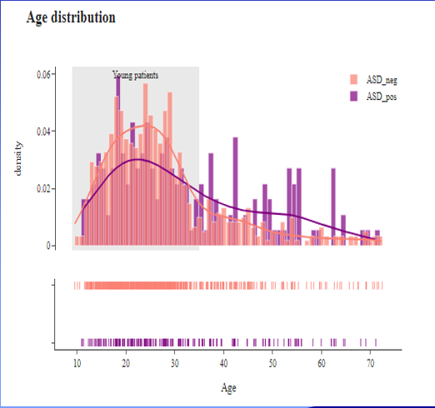

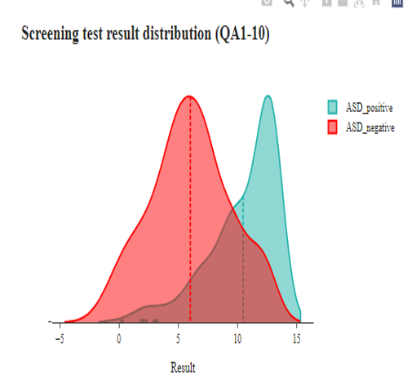

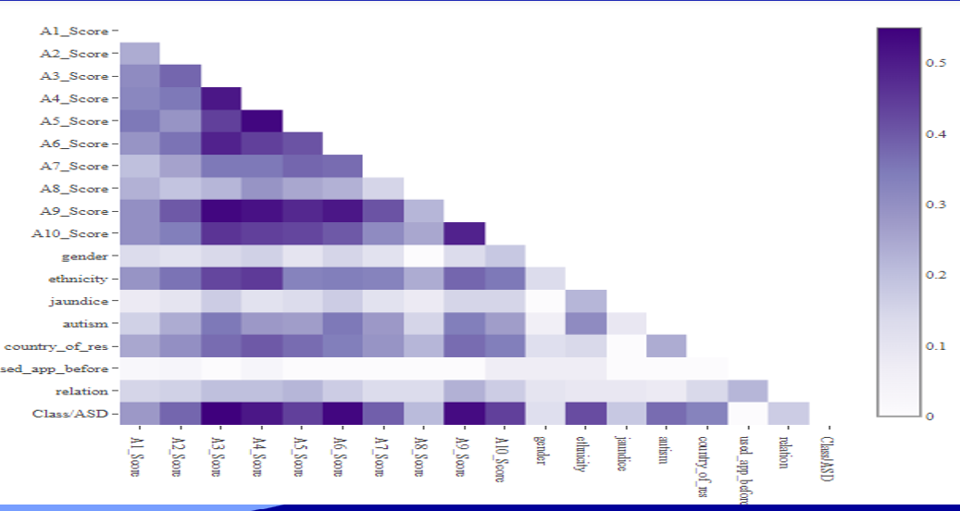

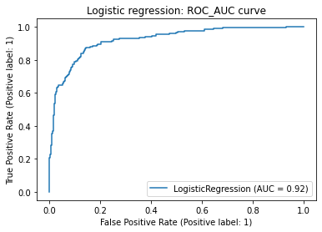

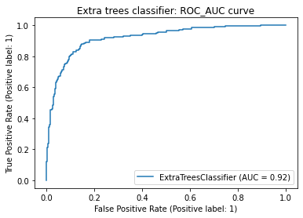

6. Conclusion and Future Work

- Conclusion:
1. Summary of Findings: Summarize the main outcomes, including the effectiveness of predictive models, identified markers, and their implications for ASD prediction and understanding.
2. Impact and Significance: Highlight the significance of the study in advancing the field of autism research, emphasizing its potential for early detection, personalized intervention, and deeper insights into ASD etiology.
3. Clinical Relevance: Emphasize the practical implications of the study for clinicians, healthcare providers, and individuals affected by ASD, focusing on how the developed models can enhance early support and tailored interventions.
- Future Work:
1. Refinement of Models: Discuss avenues for improving the predictive models by incorporating additional data sources, refining algorithms, and enhancing model interpretability and usability.
2. Longitudinal Studies: Propose conducting longitudinal studies to track the progression of ASD and validate the predictive markers identified, enabling a deeper understanding of the developmental trajectory.
3. Subtype Analysis: Explore further analysis to understand specific subtypes or variations within the autism spectrum, recognizing the heterogeneity of ASD and its implications for predictive modeling.
4. Collaboration and Validation: Advocate for collaboration with a broader network of researchers and clinicians for validation studies across diverse populations, ensuring the robustness and generalizability of the models.
5. Ethical and Social Considerations: Stress the importance of continued adherence to ethical guidelines and responsible data usage while addressing social implications and the impact on individuals and communities.
6. Integration into Healthcare Systems:Focus on the practical integration of predictive models into healthcare systems, emphasizing user training, system integration, and usability in clinical settings.
References
1. Lord, C., et al. "Autism spectrum disorder." Nature Reviews Disease Primers (2018).
2. Geschwind, D. H., & State, M. W. "Gene hunting in autism spectrum disorder: on the path to precision medicine." The Lancet Neurology (2015).
3. Anagnostou, E., & Taylor, M. J. "Review of neuroimaging in autism spectrum disorders: what have we learned and where we go from here." Molecular Autism (2011).
4. Chaste, P., & Leboyer, M. "Autism risk factors: genes, environment, and gene-environment interactions." Dialogues in Clinical Neuroscience (2012).
5. Happé, F., & Ronald, A. "The ‘fractionable autism triad’: a review of evidence from behavioural, genetic, cognitive and neural research." Neuropsychology Review (2008).
6. Bailey, A., et al. "Autism as a strongly genetic disorder: evidence from a British twin study." Psychological Medicine (1995).
7. Dawson, G., et al. "Randomized, controlled trial of an intervention for toddlers with autism: the Early Start Denver Model." Pediatrics (2010).
8. Estes, A., et al. "Behavioral, cognitive, and adaptive development in infants with autism spectrum disorder in the first 2 years of life." Journal of Neurodevelopmental Disorders (2015).
9. Mandy, W. P., et al. "The Social Communication Questionnaire in a sample of the general population of school‐aged children." Journal of the American Academy of Child & Adolescent Psychiatry (2011).
10. Lord, C., et al. "The Autism Diagnostic Observation Schedule–Generic: A standard measure of social and communication deficits associated with the spectrum of autism." Journal of Autism and Developmental Disorders (2000).
11. Zwaigenbaum, L., et al. "Early intervention for children with autism spectrum disorder under 3 years of age: recommendations for practice and research." Pediatrics (2015).
12. Lai, M. C., et al. "Biological sex affects the neurobiology of autism." Brain (2013).
13. Geschwind, D. H. "Advances in autism." Annual Review of Medicine (2009).
14. Elsabbagh, M., et al. "Global prevalence of autism and other pervasive developmental disorders." Autism Research (2012).
15. Ruggeri, B., et al. "Autism spectrum disorders in the European Union: prevalence and cost of intervention." Autism Research (2013).
16. Lai, M. C., et al. "A behavioral comparison of male and female adults with high functioning autism spectrum conditions." PLoS One (2011).
17. Bishop, S. L., et al. "Using the Autism Diagnostic Interview-Revised to increase phenotypic homogeneity in genetic studies of autism." Biological Psychiatry (2007).
18. Charman, T. "Mapping brain structure and function in early childhood: implications for outcome and treatment." Autism Research (2014).
19. Lord, C., & Bishop, S. L. "Autism spectrum disorders: diagnosis, prevalence, and services for children and families." Social Policy Report (2010).
20. Happé, F., et al. "Language and executive function in autism spectrum disorders." Journal of Autism and Developmental Disorders (2006).
21. Johnson, C. P., & Myers, S. M. "Identification and evaluation of children with autism spectrum disorders." Pediatrics (2007).
22. Ozonoff, S., & Iosif, A. M. "Changing conceptualizations of regression: what prospective studies reveal about the onset of autism spectrum disorder." Neuroscience & Biobehavioral Reviews (2019).
23. Pelphrey, K. A., et al. "Developmental social cognitive neuroscience: insights from functional neuroimaging studies." Child Development (2004).
24. Sullivan, M., et al. "Evaluation of autism diagnostic interview-revised (ADI-R) algorithms for toddlers and young preschoolers." Journal of Autism and Developmental Disorders (2007).
25. Wang, L. W., & Tancredi, D. J. "The epidemiology of autism spectrum disorders: is the prevalence rising?" Current Opinion in Neurology (2011).

